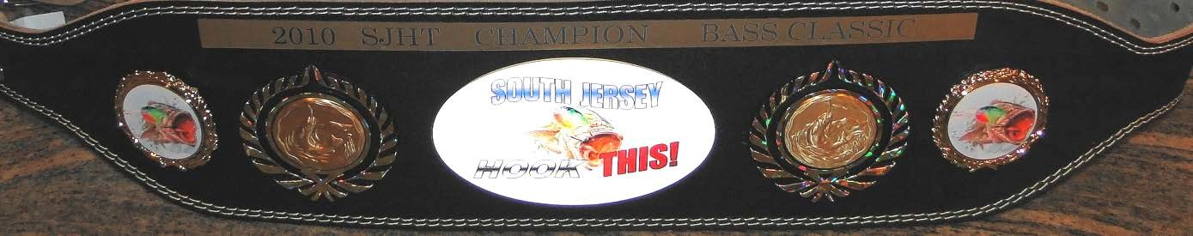
2019 SJHT 16th Annual
Union Lake Open Buddy Bass
Tournament
Saturday, June 29, 2019
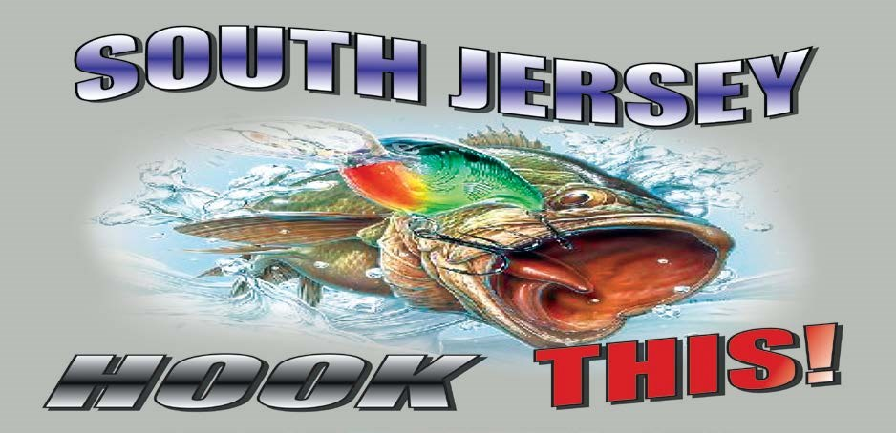

Time: 6:00am-2:00pm
Location: Union Lake, Millville, NJ
Entry Fee: $80.00 per Boat
Lunker Fee Included
Cash Payable at the Ramp beginning at 4:45AM

Fish Limit: 5 Largemouth\Smallmouth Bass
80% Payout: 1st, 2nd, 3rd, & 100% for Lunker

Website: www.SouthJerseyhookthis.com
Active Member: South Jersey Bass Club Association http://www.sjbca.org/tournschd.htm

Field Limited to 75 Boats
- See Back of this form for Tournament Rules & Waiver

South Jersey Hook This Bass Club
Union Lake, Saturday June 29, 2019, 6AM to 2PM
Please PRINT CLEARLY and remember to include your signature on the bottom line.

Boat Operator Partner

Name ________________________________ Name _________________________________________

Street _______________________________ Street __________________________________________

City ________________State _____ Zip __________ City ________________State _____ Zip__________

Phone No __________________________________ Phone No __________________________________

Signature of Boat Operator______________________ Signature of Partner________________________________

UNION LAKE OPEN BUDDY BASS TOURNAMENT
PRESENTED BY
SOUTH JERSEY HOOK THIS BASS CLUB
JUNE 29, 2019

OFFICIAL RULES

- Starting position will be assigned in the order that entry applications are received.
- Registration/boat inspection starts at 4:45 AM at the new ramp. All competitors must check in at registration table to obtain weigh-in number, weigh-in procedure instructions and any pertinent information regarding the tournament. All boats must undergo a boat inspection prior to launching.
- All boats must have an aerated live-well or cooler to sustain the life of the fish.
- Landing nets are permitted.
- Largemouth and smallmouth bass only. 5 fish per team, 12” minimum size. Fish will be measured on a flat rule, closed mouth to tip of tail in its natural state. (Cannot pinch the tail.) Any short fish weighed will result in the loss of the team’s lunker. A courtesy measurement will be allowed by request only.
- An 8 oz penalty will be assessed for each dead fish weighed in. No culling of dead fish.
- All boats must be within 50 yards of the weigh-in site with lines out of the water at 2:00 PM or will be disqualified.
- All live fish become the property of the SJHT to be released to the water. A potential state record may be kept.
- No live bait may be used or possessed at any time. Fish must be caught on artificial lures only. (Pork frogs, strips, etc. may be used.) 10. No trolling is permitted.
- No fishing is permitted within 50 yards of an anchored boat with its trolling motor out of the water.
- A wearable approved floatation device is required on board for each competitor. All laws of the State of New Jersey and the Division of Fish & Wildlife must be obeyed at all times. Boats must be in a safe operating condition.
- The use or possession of any alcoholic beverages or controlled dangerous substances during this tournament will result in immediate disqualification.
- All disputes and protests must be registered with the tournament director prior to completion of the weigh-in. All decisions will be made at the tournament site. The decision of the tournament director and the SJHT will be final.
- Winners are determined by total weight of fish (per team). Ties are broken by weight of the lunker fish. Lunker ties are broken by the lowest boat number.

Having acquainted ourselves with the rules and regulations of this tournament, I hereby waive and release the South Jersey HOOK THIS Bass Club, its officers, sponsors and other contestants from all damages, claims, demands, costs or expenses relating to injury of any person or property which I may sustain or cause by participating in this tournament. I also understand that I will forfeit my entry fee if I fail to appear at the specified date and time.

